4.1 Maclaurin and Taylor Polynomials

Chapter 3 was concerned with the development of ideas surrounding the convergence or divergence of various different kinds of series. In what way is this knowledge relevant? How can it be used to provide meaningful real world results?

Recall (Local Linear Approximations):
For some functions it may be simple to evaluate but difficult to compute values of f near a.
Instead we will use the equation of the tangent line at to estimate f near a.

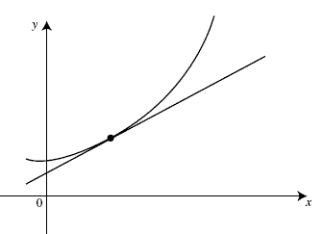
$$\left(a,f\left(a\right)\right)$$
$$y=p\left(x\right)$$
$$y=f\left(x\right)$$
Notice that we can form the equation of the tangent line at by the following:

and thus

Notice that for values of x close to a, .

Example 1: Find the local linear approximation of at .

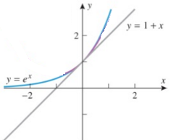
If , then .
Therefore, our linear approximation has slope and passes through the point .
Therefore the equation of the local linear approximation is:

This means that for values close to 0, .

For example: which means .

Note (again): only approximates well when values close to 0.
approximates poorly when values are far from 0.

The question we would like to ask is if there is any way to improve our ability to approximate values of .
Local Quadratic Approximations:

It seems that we would need to make a quadratic, , that has the same tangent line as at , but also has the same “bend” or concavity as near . This would mean that and should have the following properties in common:

The curves should have the same  y-value at | The curves should have tangent lines with the same slope at | The curves should have the same concavity at

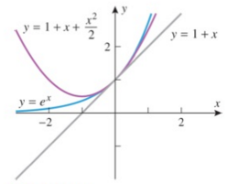
Let our new quadratic have the equation: .
Using the properties above we can establish:

So .

Therefore, for -values close to 0, , which means that !
Notice that this approximation can approximate values further from 0 with greater accuracy than the local linear approximation!

Example 2: Find the local quadratic approximation of at .


If , then , and
Therefore, we have:

Therefore the equation of the local quadratic approximation is:

This means that for values close to 0, , which means .
Question: How might we be able to obtain a way to approximate values of even further from ?

Answer: We could continue to construct polynomials with even higher degrees than a quadratic! Why not use a cubic, or a even a polynomial with degree 100?!

Our new problem: What does the formula look like for a local approximation with a polynomial of degree n?

Let

Like before, to ensure that “bends” in the same way as we need to make sure that:
, , , … ,

We then look at the derivatives of

.
.
.

Therefore the equation of the local nth degree polynomial approximation is:

Definition: If f can be differentiated n times at 0, then we define the nth Maclaurin polynomial for f to be

Example 3: Find the Maclaurin polynomials , , , and for .
Let

Clearly and

Therefore,

This means that

Note: Not all approximating polynomials need to be approximating a curve at .
We can consider approximating a curve at an arbitrary .

Definition: If f can be differentiated n times at, then we define the nth Taylor polynomial for f about
$x=x_{0}$ to be:

Example 4: Find the first four Taylor polynomial for about .

Let
Thus,

This pattern will continue for further derivatives of .

Example 5:
Determine the nth Taylor polynomial for about and express it in sigma notation.
Let . Thus,
So we have,

So the Taylor polynomial is:

Example 6: Find the nth Maclaurin polynomials for …
Let
Thus,

This pattern will continue for further derivatives of .
We can write a cleaner general formula for these polynomials:
for .

Let
Thus,
This pattern will continue for further derivatives of .

We can write a cleaner general formula for these polynomials:
for .
Example 7 (you try):
Determine the nth Taylor polynomial for…
- about and express it in sigma notation.

Let . Thus,
So we have,

So the Taylor polynomial is:

- about and express it in sigma notation.

Let
Thus,

This pattern will continue for further derivatives of .

We can write a cleaner general formula for these polynomials:
for .

